**MATH 30-2** Mr. Schellenberg

403-622-0040 (cell)

Credits: 5 [jason.schellenberg@horizon.ab.ca](mailto:jason.schellenberg@horizon.ab.ca)

Mathematics 30-2 is a new course with an emphasis on problem solving, inquiry learning, and thinking skills. This academic diploma course is intended for students who plan to pursue a post-secondary education in a field which is not directly related to mathematics. (eg. nursing, humanities, or fine arts). Students enrolled in Math 30-2 course must have completed Math 20-1 or 20-2 with a mark above 50%. **However, it is strongly recommended that students enrolled in Math 30-2 have successfully completed 20-2 with at least a 65% average.** Students enrolled in Math 30-2 are expected to complete the daily assigned homework to prepare for quizzes and exams. Students who are absent are expected to complete the missed assignments/homework on their own as soon as possible.

The number of days to complete each topic is an approximation and may be changed at the discretion of the teacher.

|  |  |
| --- | --- |
| **TOPIC** | **NUMBER OF DAYS** |
| Unit 1 – Logical Reasoning and Set Theory | 8 |
| Unit 2 – Permutations and Combinations | 10 |
| Unit 3 - Probability | 8 |
| Unit 4 – Rational Expressions and Equations | 12 |
| Unit 5 – Exponential Functions | 10 |
| Unit 6 – Logarithmic Functions | 11 |
| Unit 7 – Polynomial and Sinusoidal Functions | 11 |
| Review, Midterm and In-Class Final | 12 |

**TEXT:** *Principles of Mathematics 12*

*Math 30-2 Workbooklets*

You are responsible for your text and should bring it to class every day (along with the other necessary supplies listed below). Please do not write in your text as you are *borrowing* it and are expected to return it in good condition at the end of the semester.

**REQUIRED MATERIALS:**

* binder (with some loose leaf paper)
* **pencil**, eraser, red pen, blue pen
* ruler
* package of graph paper (1/4 inch squares or .5 cm squares)
* **graphing calculator** (TI-83plus or TI-84plus)

*There is a short list of approved calculators for Math -1 and -2 strands. If you have a different calculator, please see me and we can check to see if it’s approved*



***“Life doesn’t require that we***

***be the best,***

***only that we try our best.”***

*– H. Jackson Brown*

**HOMEWORK AND ASSIGNMENTS:**

**Daily assignments and exercises are an integral part of this course.** Doing the assignments gives you a chance to make sure you understand the concepts presented in class. Math is cumulative so you must understand today’s work in order to do tomorrow’s. In general, the responsibility for learning and completing assignments is on you, the student. Time will be provided in class to work on assignments but **work not done in class must be completed at home**.

**MISSED CLASSES OR TESTS:**

If you miss a class, you are responsible for finding out what work you missed and completing all assignments. If you miss a test or exam, you are responsible for arranging a time to write the exam. Missed tests/exams are written during the students’ own time (not during class as too much new material is missed). Please approach me in advance if you know of specific times when you will be away.

**EXTRA HELP:**

If you are having difficulty with material, please arrange a time (ahead of time) for extra help outside of class. I am available during FLEX and after school and will **post available days.**

**EVALUATION:**

1. School Awarded Grade
   1. Unit Marks **(10 – 12% each)**
      1. Unit Exams 80%
      2. Quizzes, Assignments & Homework 20%

* 1. Midterm & Review **(9%)**

Note: The midterm exam will be written in June during the review time. The midterm exam covers the first half of the course content and is intended to help you prepare for the diploma exam.

* 1. In Class Final **(15%)**

Note: The in-class final is a practice diploma exam based on the entire course. It is intended to help you prepare for the diploma exam.

1. Final Mark
   1. School Awarded Grade 70%
   2. Diploma (**Friday, June 24, 2016**) 30%

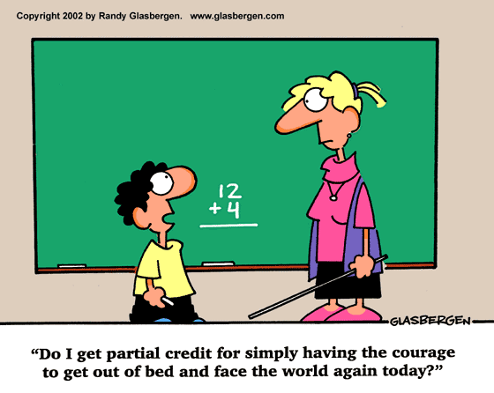

**CHOOSING THE RIGHT COURSE:**

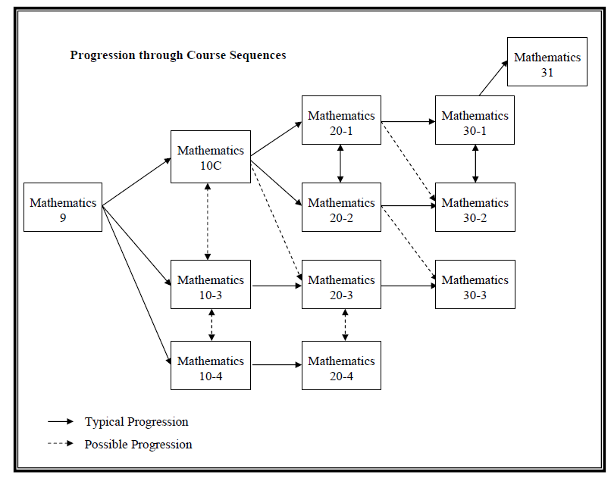

**Mathematics-1** if I want to study mathematics or sciences at a university, college, or technical institute and go on to a related career.

**Mathematics-1** is for students who plan to enter post-secondary programs such as engineering, mathematics, sciences, some business studies, or other programs that require advanced math skills. The sequence is a co-requisite for Mathematics 31 and may be required for post-secondary calculus courses.

**Mathematics-2** if I want to attend a university, college, or technical institute after high school, but do not need calculus skills.

**Mathematics-2** is for students wishing to study at the post-secondary level in diverse fields, including arts programs, civil engineering technology, medical technologies, and some apprenticeship programs. This path will fulfill most students' needs. Mathematics-2 is designed with a great deal of flexibility, so that the student can switch sequences in Grade 11 or Grade 12 if his or her interests change.

**Mathematics-3** if I am interested in learning the mathematics needed to enter most trades or if I want to enter the workforce after high school.

**Mathematics-3** is for students who want to apprentice to a trade or enter the workforce directly after high school. It is designed to meet the entrance requirements for apprentices in most trades programs, specifically levels one to three.