PHYSICAL EDUCATION 10-30
Mr. Schellenberg

RATIONALE:
The aim of Physical Education in Alberta is to enable individuals to develop the knowledge, skills and positive attitudes necessary to lead an active, healthy lifestyle. There is strong evidence to support the assertion that physical activity contributes to the overall well-being of individuals. Here are some reasons why students need physical activity on a regular basis: Health Promotion, Active lifestyle, Skill development, Positive Interactions, Self-confidence/esteem, Goal setting, and academic achievement.
As set out by Alberta Education, here are the general outcomes to be achieved in the physical education curriculum.
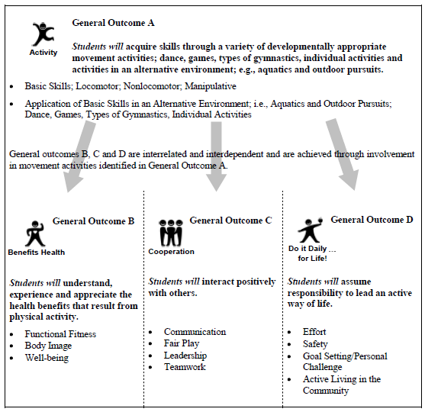

ACTIVITIES:
Fitness Training, Flag Football, Frisbee Football, Softball, Soccer, Ball Hockey, Volleyball, Basketball, Handball, Lacrosse, Badminton, Off Campus Activities

EVALUATION:
Development of student knowledge ………………………………... 20%
Development of student skills ……………………………………………. 20%
Development of attitude / sportsmanship (participation) …… 60%

Attendance and Participation is essential for success in Phys. Ed. If you are unable to attend/participate a note is required from your parents.

YEAR SCHEDULE:
MONTH | FOCUS
September | Fitness  Flag Football  Ultimate Frisbee  Soccer
October | Volleyball  Fitness  Handball
November | Basketball  Volleyball  Fitness
December | Basketball  Lacrosse  Dance  Tchukball
January | Basketball  Badminton  Fitness
February | Volleyball  Fitness  Handball
March | Basketball  Volleyball  Fitness
April | Basketball  Lacrosse  Dance  Tchukball
May | Fitness  Flag Football  Ultimate Frisbee  Softball  Soccer
June | Outdoor Activities: Year wrap up

DAILY PARTICIPATION RUBRIC:

5  Outstanding | - Gives top effort 100% of the time – self motivated  - Always prepared for class  - Prompt arrival  - Communicates appropriately and respectfully  - Displays leadership as well as fellowship skills  - Recognizes others contributions in a positive way
4  Excellent | - Works and plays hard at least 80% of the time  - Effort as outlined in 5 is fairly consistent
3  Acceptable | - Late for class but still participates at 100% effort  - Exerts good effort if teacher watching, if winning, if interested … “iffy” effort  - Minimal improvement in physical skills  - Occasionally disrupts instruction  - Requires prompting for acceptable level of effort
2  Needs More Effort | - Not changed out but still participates at 100% effort  - Going through the motions … now sweat  - Just trying to survive  - No improvement in physical skills  - Contributes little to class  - Numerous “excuses” for lack of effort
1  Ouch | - Often slow getting organized  - Avoids participation  - Excessive socializing  - Interfering with others by fooling around or goofing off  - Favorite saying – “I can’t, “I’m bored”, “this sucks”
0  Oh No! | - Changed / not changed – does next to nothing in class  - Zero to very little self-initiation  - Very little on-task behavior  - Behavior issues

